**RTOS Hands on FreeRTOS and STM32Fx with Debugging**

Contents

1. RTOS Introduction
2. IDE install
3. Development board used
4. Downloading and Installing FreeRTOS
5. Creating FreeRTOS based project for STM32 MCUs

1.RTOS Introduction

To be considered as "real time", an operating system must have a known maximum time for each of the critical operations that it performs. Some of the operations may include handling of interrupts and the internal systems exceptions.

GPOS vs RTOS Task Scheduling:

(Throughput means-the total number of processes that complete their execution per unit time.)

GPOS is programmed to handle scheduling in such a way that it manages to achieve high throughput. In such cases sometimes execution of high priority process will get delayed in order to serve 5 or 6 low priority task. High throughput is achieved by serving 5 lower priority tasks than by serving a single high priority one. 5 or 6 low priority tasks are waiting to run, so then it will delay the high priority task and it will allow the lower priority task to run because, in order to maintain the higher throughput. So, In a GPOS, the scheduler typically uses a fairness policy to dispatch threads and processes onto the CPU.

RTOS, Threads execute in the order of their priority. If a high-priority thread becomes ready to run, it will take over the CPU from any lower-priority thread that may be executing .Here a high priority thread gets executed

2.IDE install

[https://www.st.com/en/development-tools/stm32cubeide.html#st-get-software](https://www.st.com/en/development-tools/stm32cubeide.html" \l "st-get-software)

3. Development board used

NucleoBoard STM32F411RE

* The STM32F411XC/XE devices are based on the high-performance Arm® Cortex® -M4 32- bit RISC core operating at a frequency of up to 100 MHz .
* The STM32F411xC/xE incorporate high-speed embedded memories (up to 512 Kbytes of Flash memory, 128 Kbytes of SRAM),.
* one 12-bit ADC, a low-power RTC, six general-purpose 16-bit timers .
* Up to three I2Cs .
* Five SPIs
* Five I2Ss out of which two are full duplex. To achieve audio class accuracy, the I2S peripherals can be clocked via a dedicated internal audio PLL or via an external clock to allow synchronization.
* Three USARTs .
* SDIO interface .
* USB 2.0 OTG full speed interface .

4.Downloading and Installing FreeRTOS

https://github.com/FreeRTOS/FreeRTOS/releases/download/202212.01/FreeRTOSv202212.01.zip

5.Creating FreeRTOS based project for STM32 MCUs

Creation of Project:

1. New>>STM32 Project

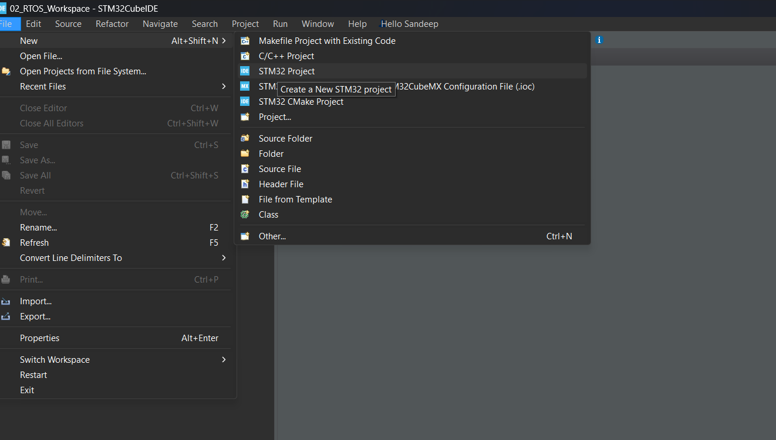

2. Select Development Board >>Next

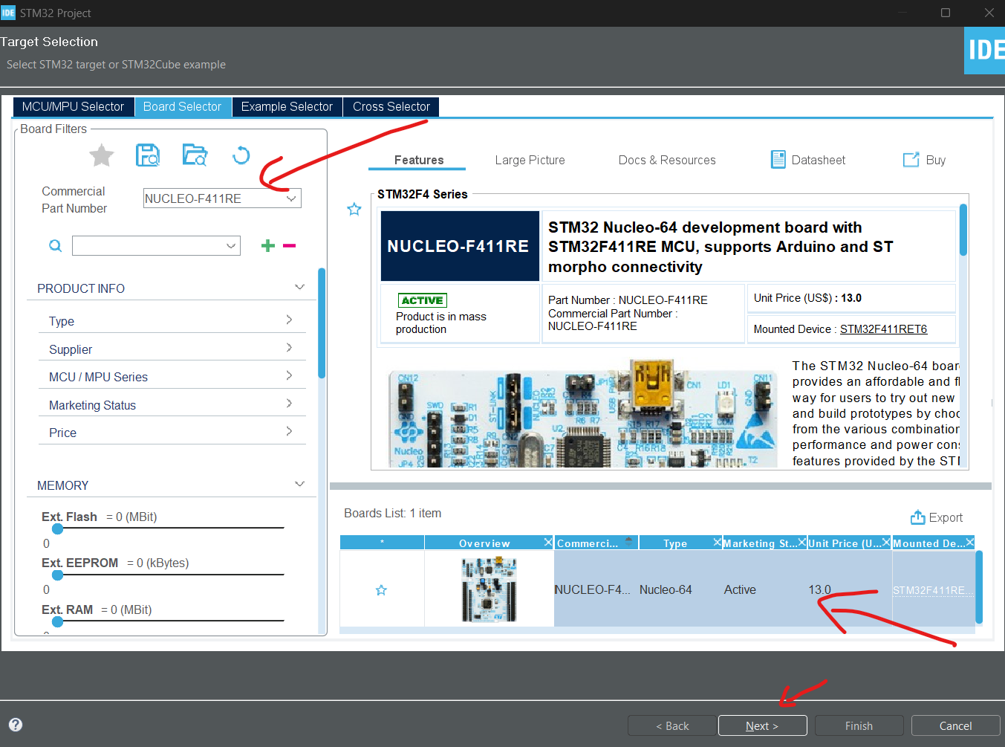

3. If Code needs to be build fom ground Then select Empty in target Project Type else if need to use Device Configuration then select STM32Cube

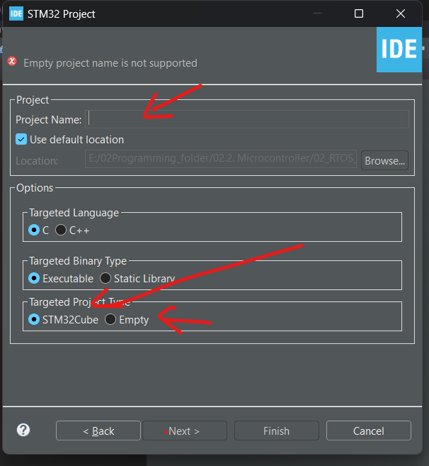

4.

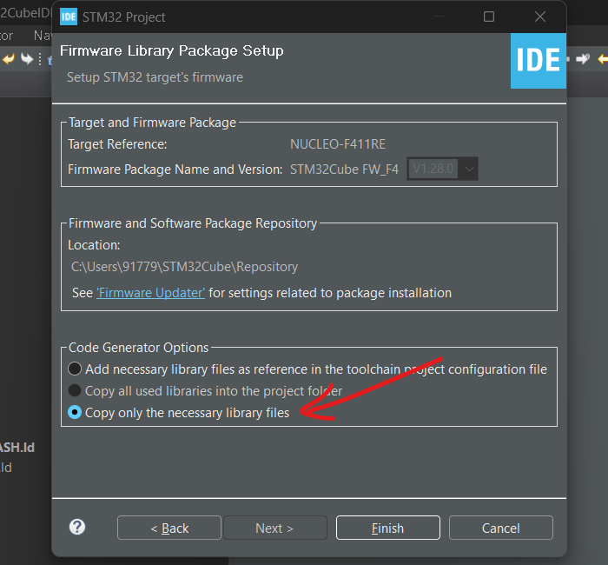

5.

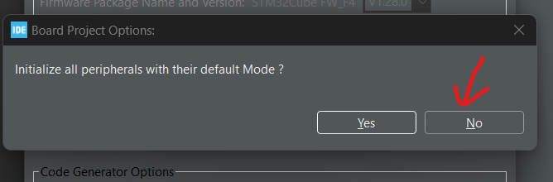

Steps to include FreeRTOS in Project

1. Using STM32CUbe Device Config.

Device Config>> Middleware and Software >>CMSIS V1 or CMSIS V2.

2. Manually Non CMSIS.

1. Create a folder :

B. Copy Below contents from FreeRTOS folder to Crteated Folder ThirdParty inside Project.

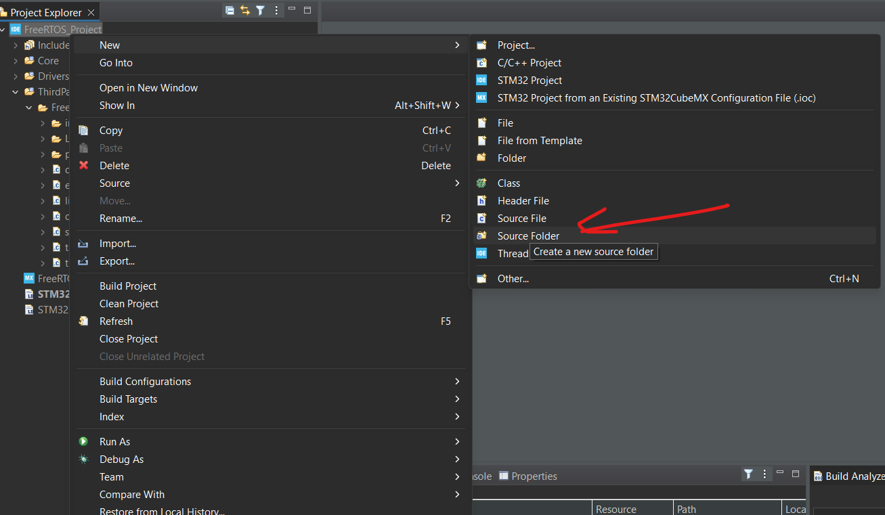

C. Delete unnecessary folders in Portable and keep GCC since we’ll be using GCC .

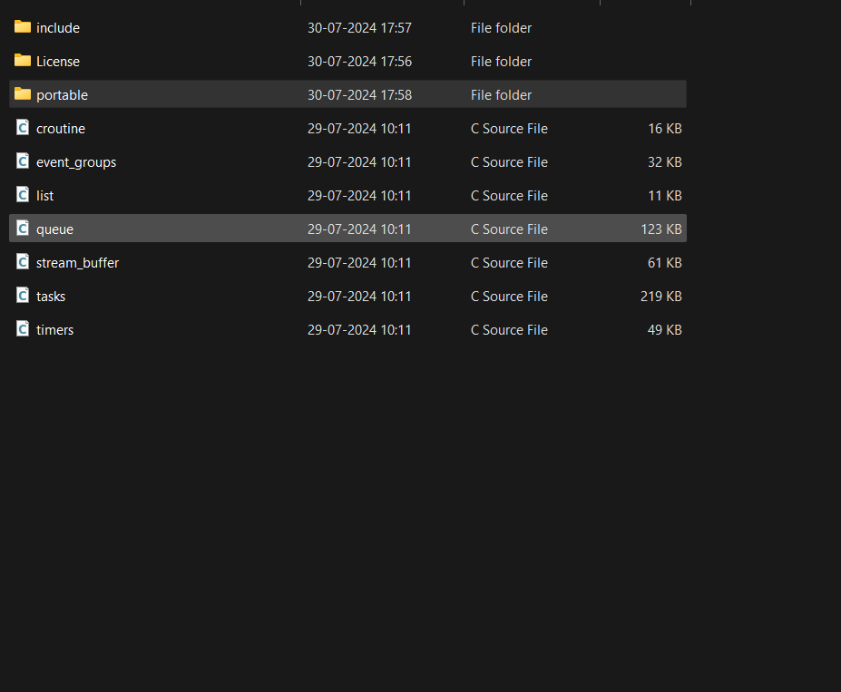

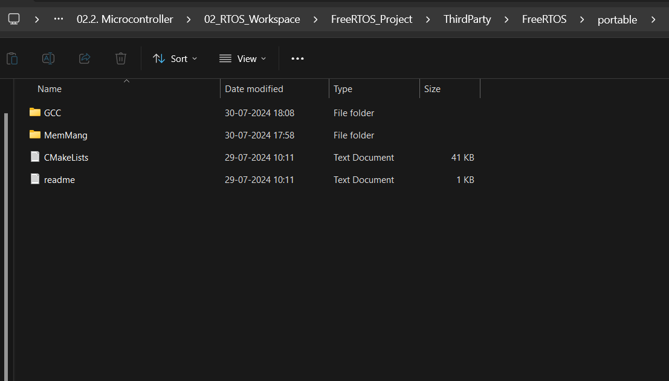

D. Keep ARN SM$F which is ARM Cortex M4 with Floating point processor and delete remaining

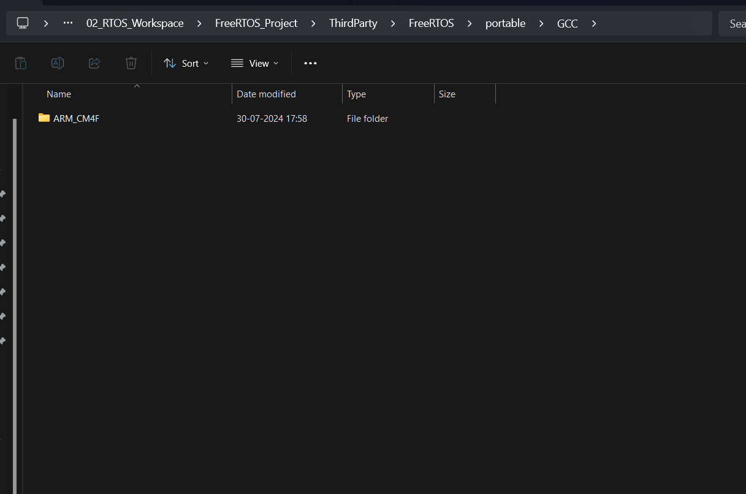

E. Refres in STM32CubeIDE and the ThirdParty folder will appear, right click on it and go to properties andinto C/C++ Build make sure if Exclude resource from build is uncheck.

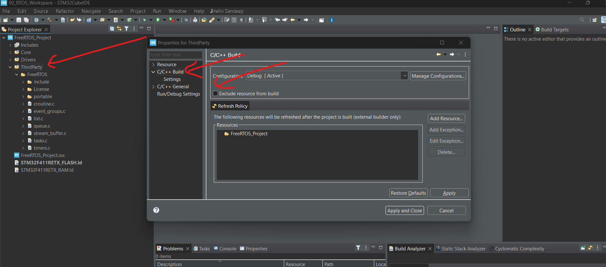

IN STM32CubeIDE >>Core>>Src contains some imp files

* main.c
* stm32f4xx_hal_msp.c
* stm32f4xx_it.c
* syscalls.c
* sysmem.c
* system_stm32f4xx.c

**>** In the main.c, we will be adding our application code.

**>** stm32f4xx_it.c contains all the interrupt handlers and system exception handlers.

**>** stm32f4xx_hal_msp.c contains the device initialization code for different peripherals.

**>** syscalls.c this file actually implement some of the standard library system calls, such as write, read, etc this fle actually implement some of the standard library system calls, such sysmem.c is used for heap management. For this project the FreeRTOS provides its own heap management code.That is a code which handles a dynamic memory allocation.

That's why, we don't need this sysmem.c for this project. Just right click over that, select properties, and you can check this option exclude resource from build.

Will exclude that. Because, the FreeRTOS gives you the heap management code, which is there in a portable, Mem management folder. for this project we will be using heap_4.c in ThirdParty>>FreeRTOS>>Portable>>MemMang>>heap_4.c

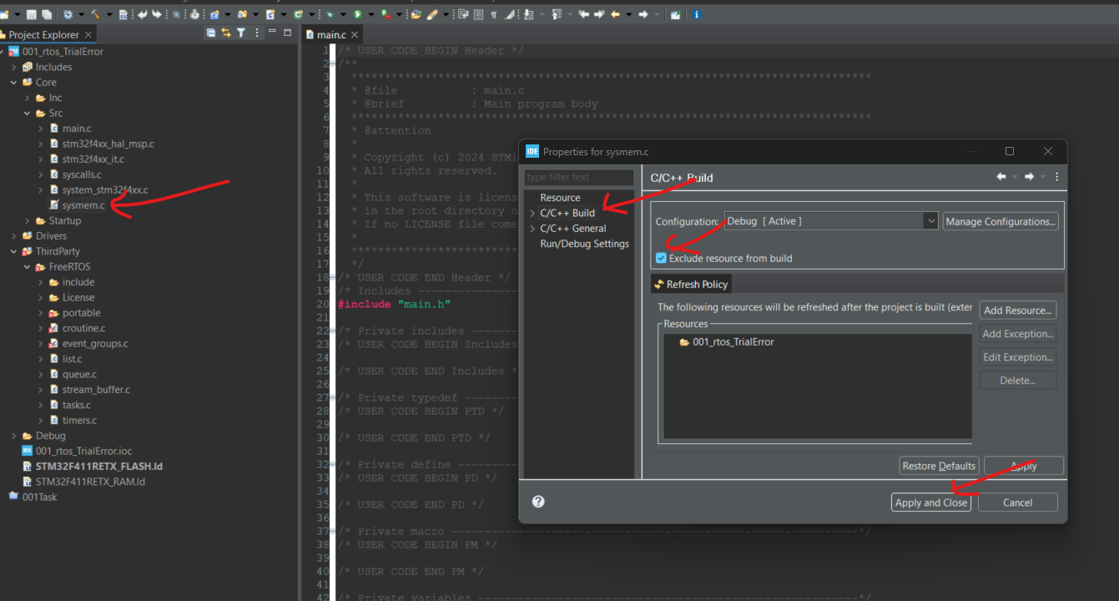

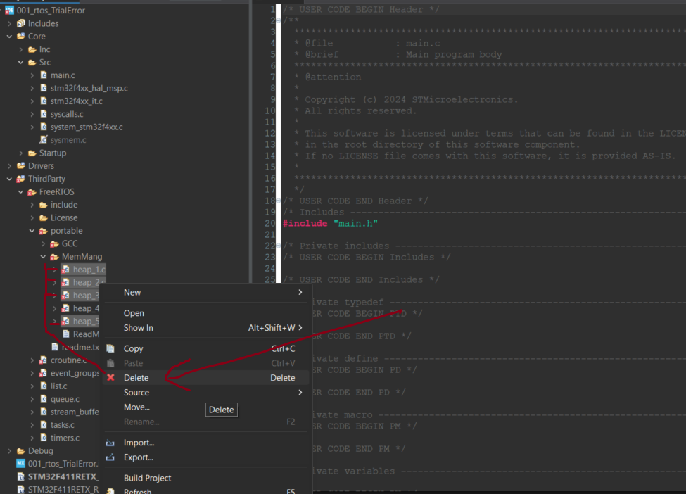

Solving ERRORS

1. Adding FreeRTOS headers

ERROR:

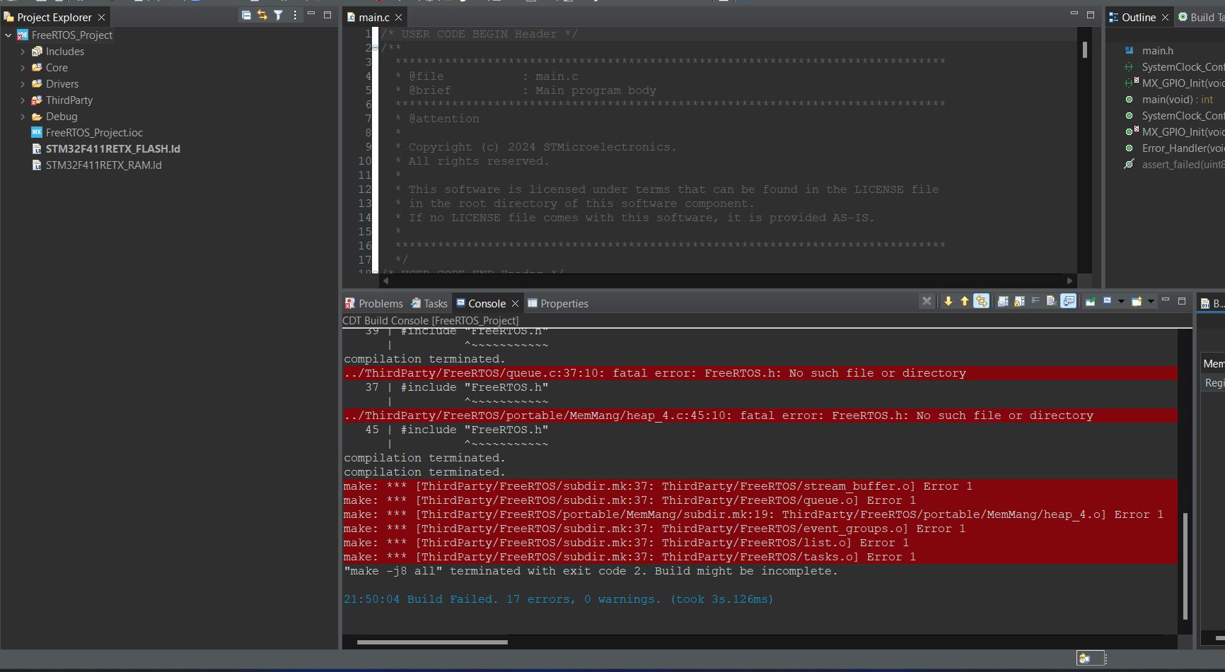

SOLUTION:

a)

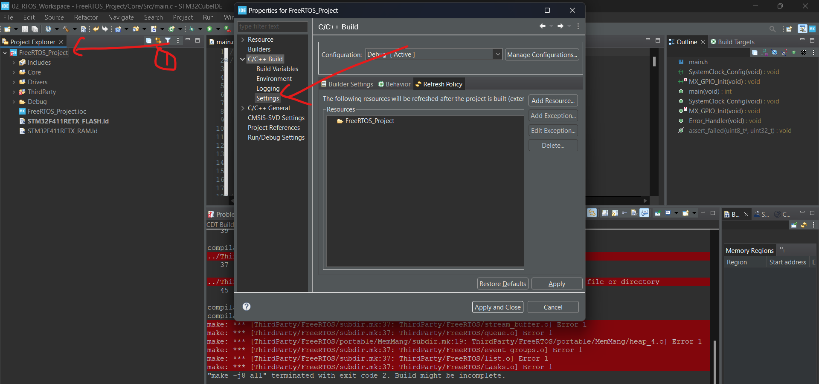

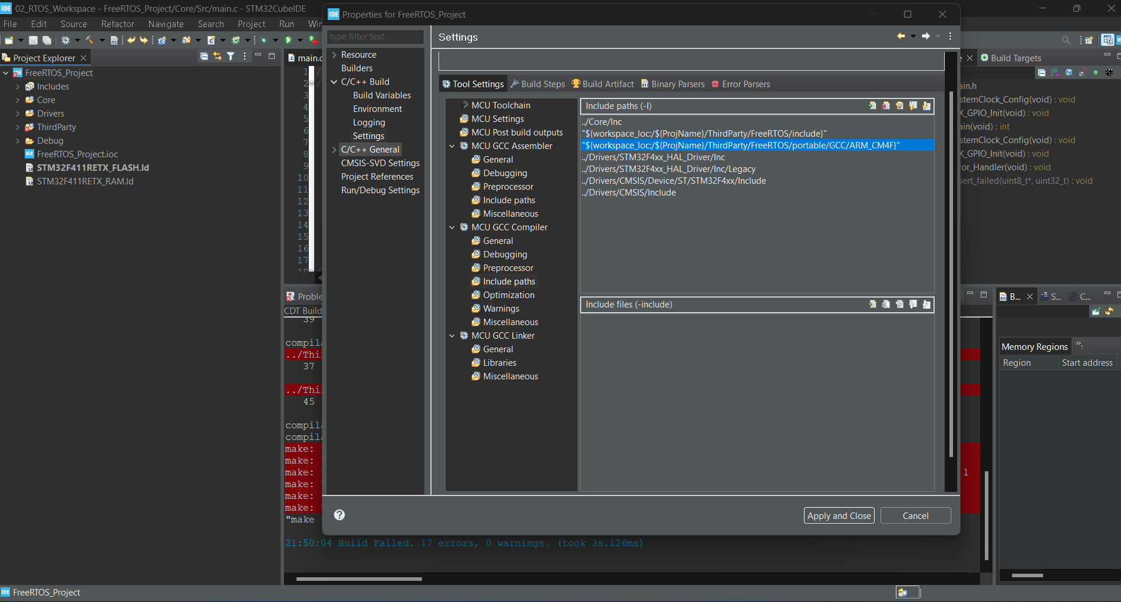

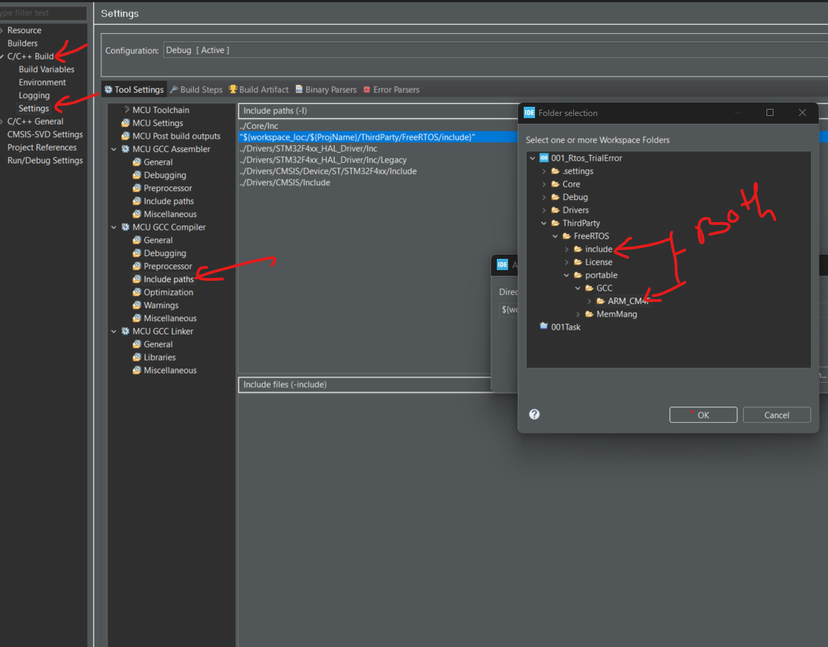

1. Adding FreeRTOSconfig header:

First of all, what is this FreeRTOSConfig.h? As its name indicates, it's a configuration file to customize the FreeRTOS kernel. Basically it's a C header file. This header file contains a various configuration items by which you can customize the FreeRTOS kernel.

ERROR:

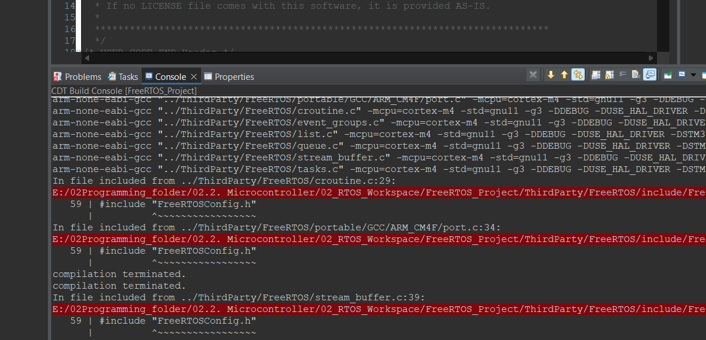

SOLUTION:

Copy FreeRTOSconfig.h from Demo and respective MCU(search it) STM32F407 is best i got. And past in ThirdParty>>FreeRTOS. And add the header as above.

* Next is SystemCoreClock Error

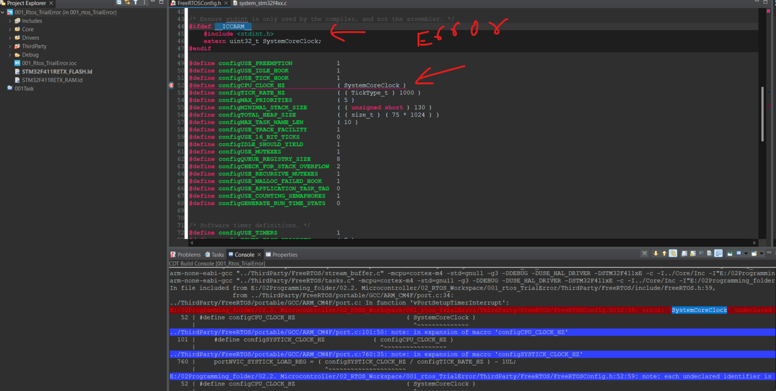

Solution:

**#if** defined(__ICCARM__) || defined(__GNUC__) || defined(__CC_ARM)

**#include** <stdint.h>

**extern** **uint32_t** SystemCoreClock;

**#endif**

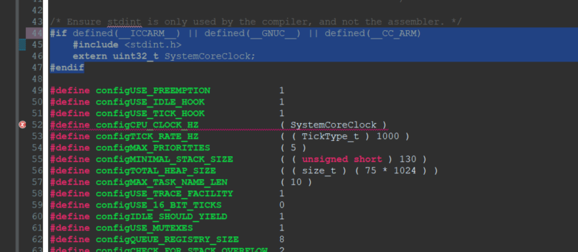

1. Exception Handlers:  
   SVC exception, PendSV exception, and SysTick timer exception.These are some of the exceptions of the Arm Cortex Mx processor.And to handle those exceptions we write SVC_Handler, PendSV_Handler, and SysTick timer handler.And these exception handlers are used to support FreeRTOS at the architecture level.

* the PendSV_Hander is used to implement the FreeRTOS scheduler
* the SysTick_Handler is used to launch the scheduler at given intervals. Basically the SysTick timer of the processor is configured to generate SysTick interrupts, which is used to launch the scheduler at defined intervals, and also it is used for time keeping functionality.

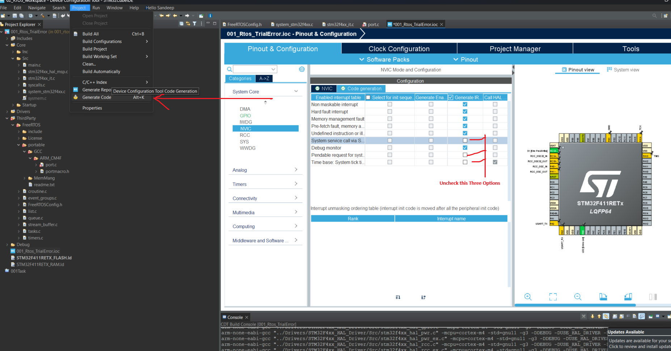

* Now we have undefined references as ERROR

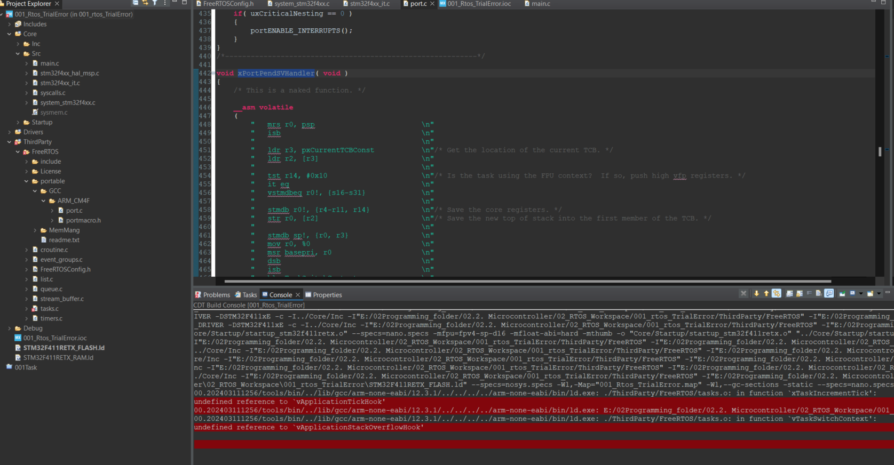

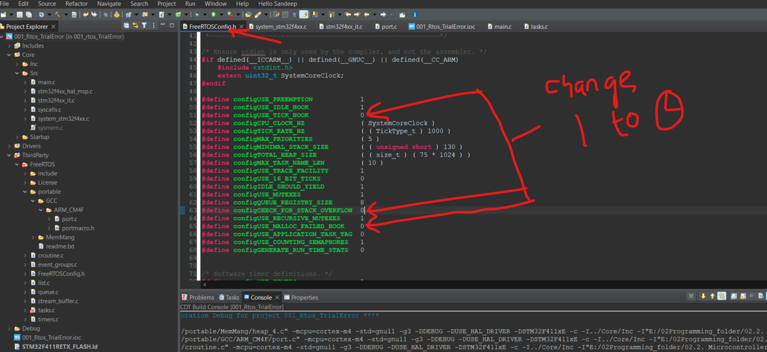

1. Timer Base Source Selection:

* FreeRTOS kernel uses Arm Cortex Mx processor's internal systick timer as its time-base,that is for RTOS ticking.This systick timer will be used by the FreeRTOS kernel to implement various timing related functionality, such as a implementing a task delay, or you know scheduling a task at different intervals.
* In our project, we are also using the hardware abstraction layer, which is given by the STM32Cube software. The hardware abstraction layer we can use to communicate with various peripherals of the microcontrollers.To carry out those timing related things it has to use a timer..
* We cannot use systick timer for both FreeRTOS and for STM32 Cube HAL layer. such as ADC, Dac, Timers, UART, USB, etc

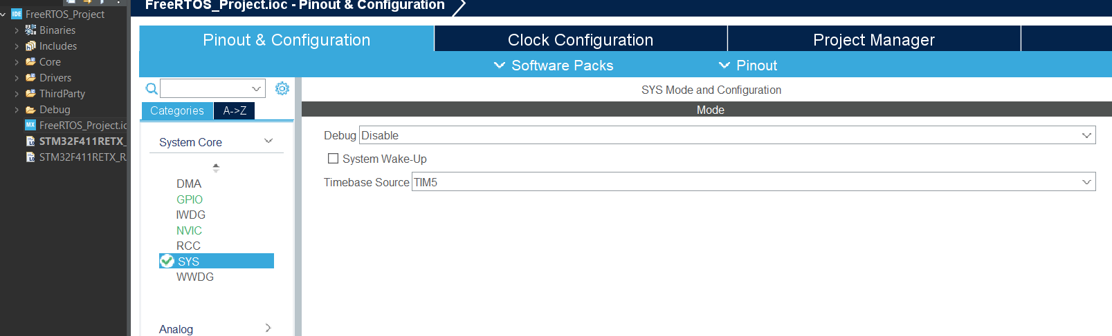

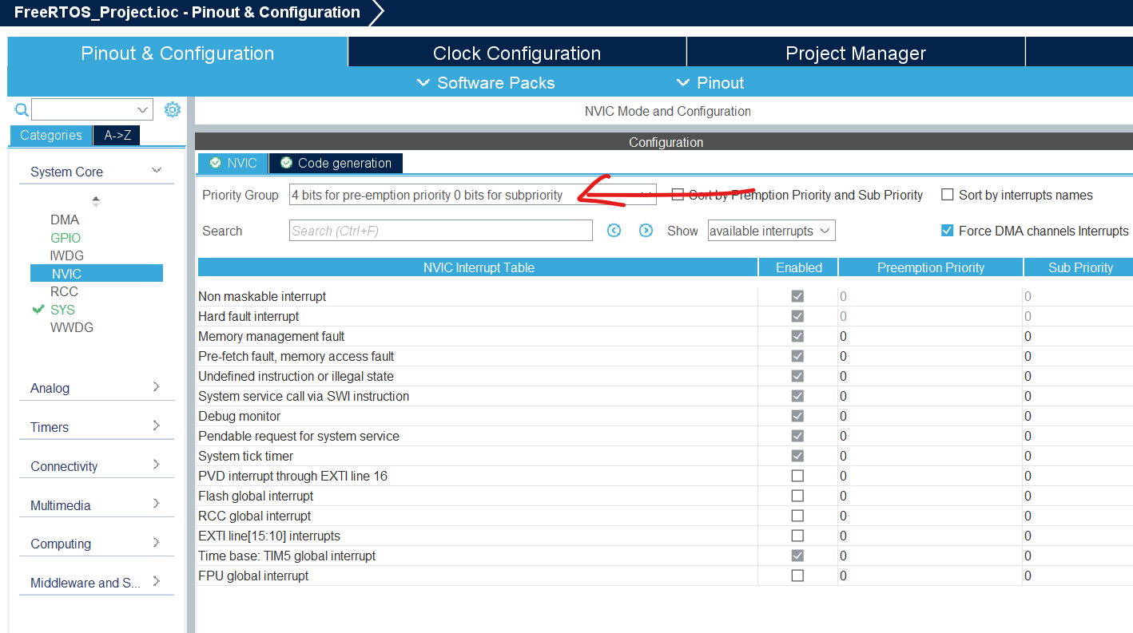

Printf Over SWO

1)Past below code in syscall.c below #Include

/////////////////////////////////////////////////////////////////////////////////////////////////////////

// Implementation of printf like feature using ARM Cortex M3/M4/ ITM functionality

// This function will not work for ARM Cortex M0/M0+

// If you are using Cortex M0, then you can use semihosting feature of openOCD

/////////////////////////////////////////////////////////////////////////////////////////////////////////

//Debug Exception and Monitor Control Register base address

#define DEMCR *((volatile uint32_t*) 0xE000EDFCU )

/* ITM register addresses */

#define ITM_STIMULUS_PORT0 *((volatile uint32_t*) 0xE0000000 )

#define ITM_TRACE_EN *((volatile uint32_t*) 0xE0000E00 )

void ITM_SendChar(uint8_t ch)

{

//Enable TRCENA

DEMCR |= ( 1 << 24);

//enable stimulus port 0

ITM_TRACE_EN |= ( 1 << 0);

// read FIFO status in bit [0]:

while(!(ITM_STIMULUS_PORT0 & 1));

//Write to ITM stimulus port0

ITM_STIMULUS_PORT0 = ch;

}  
  
*//replace writechar function in write () with SendChar(*ptr);

2) include #include <stdio.h> in main.c

make #define configUSE_IDLE_HOOK 0 in freeRTOSconfig.h

3)Config i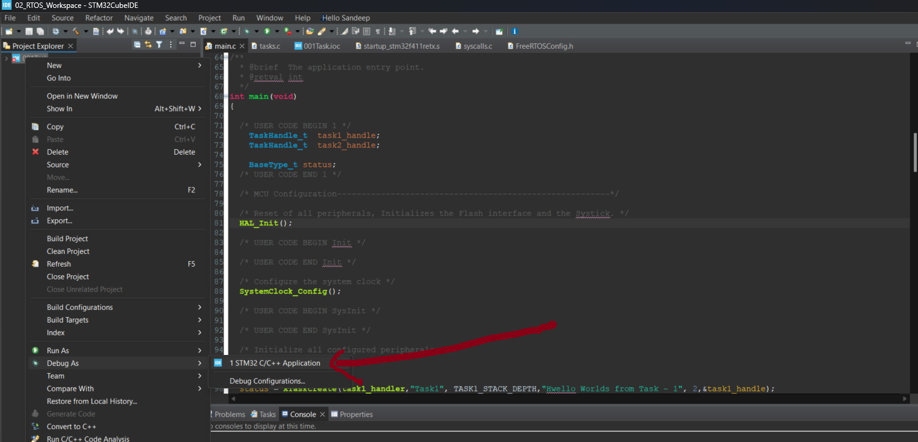n IDE

1. 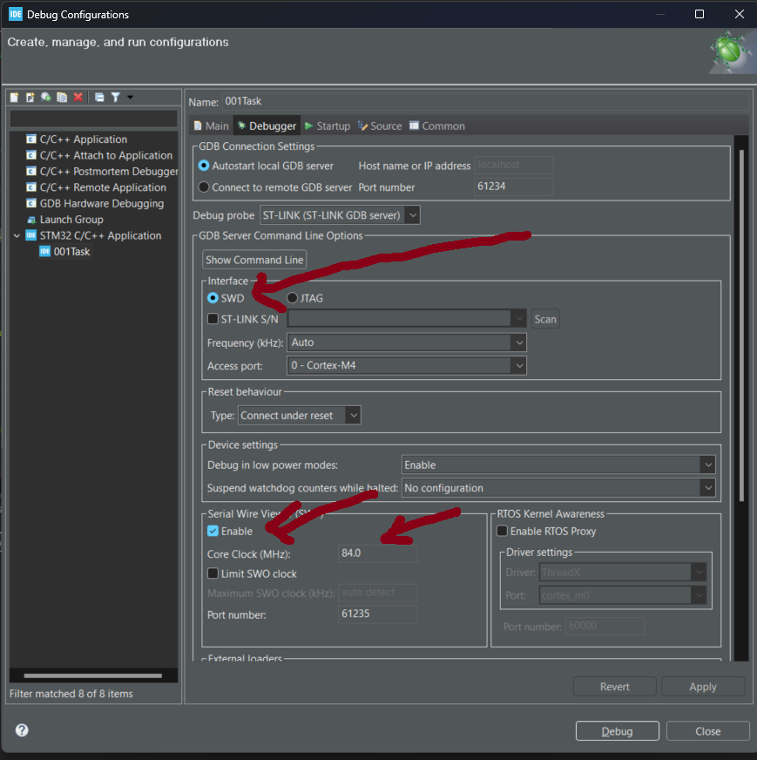
2. SEGGER System View

Download:

https://www.segger.com/downloads/systemview/

1. User manule.
2. System view for Win
3. SystemView, Target Sources.

The SystemView can be used to analyze how your embedded code is behaving on the target.

Example: In the case of FreeRTOS application

* You can analyze how many tasks are running and how much duration they consume on the CPU.
* ISR entry and exit titming and duration of run on the CPU.
* You can analyze other behaviour of tasks : like blocking, unblocking, notifying, yielding etc.
* You can analyze CPU idle time so that you can think of sending CPU to sleep mode.
* Total runtime behaviour of the applicatrion.
* It sheds light on what exactly happening in which order, which interrupt has triggered which task switch, which interrupt and task has called which API function of the underlying RTOS.
* SystemView should be used to verify that the Embedded systems behave as expected and can be used to find problems and inefficiencies, such as superfluous and spurious interrupt and unexpected task changes

SystemView Visualization Mode

1. Realtime recording

For Real time recording we should have SEGGERs J-Link debugger. So, with a SEGGER J-Link and its Real Time Transfer technology SystemView can continuously record data,analyze, and visualize in real time. So, the first requirement to use real time or continuous debugging is you should have J-Link debugger,which is connected to your target hardware. So, but remember that, real time mode can be achieved on ST-Link instead of J-Link. Now, for that J-Link firmware has to be flashed on ST-Link circuitry of STM32 boards.

1. Single short recording

In single-shot mode the recording is started manually in the application, which allows recording only specific parts, a which are of interest. Now in the Single-shot recording, as it name indicates, in order to take the snapshot of the events of interest in your application.

SEGGER SystemVIew Target Integration

Step -1: Adding SEGGER SystemView target sources to the project

1. Download SystemView target sources and extract it
2. Create the folders as shown below in your FreeRTOS Project
3. Do the path setting for the include files of SEGGER in the IDE.

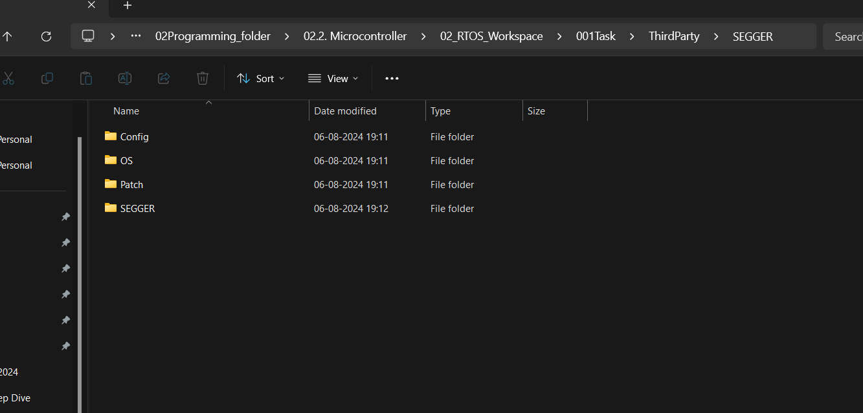

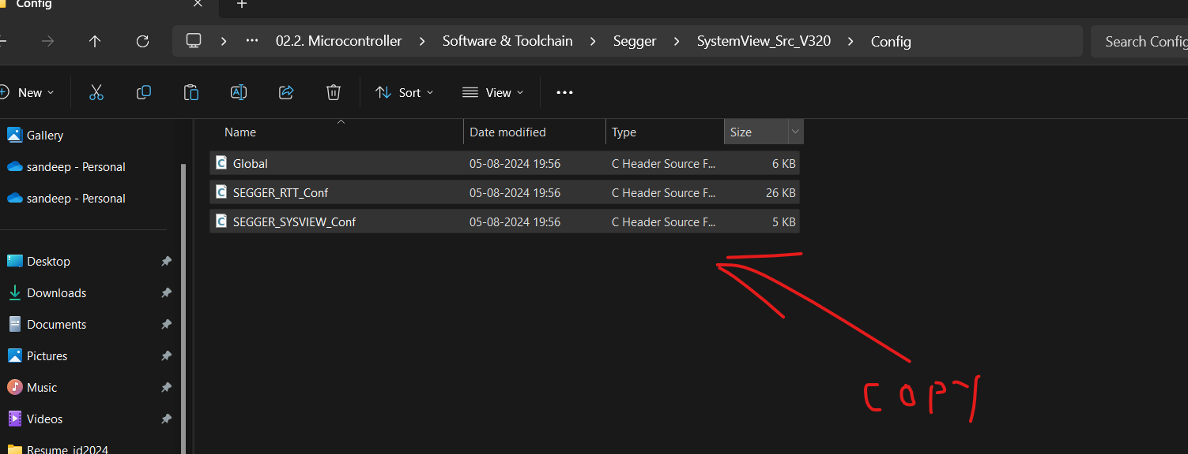

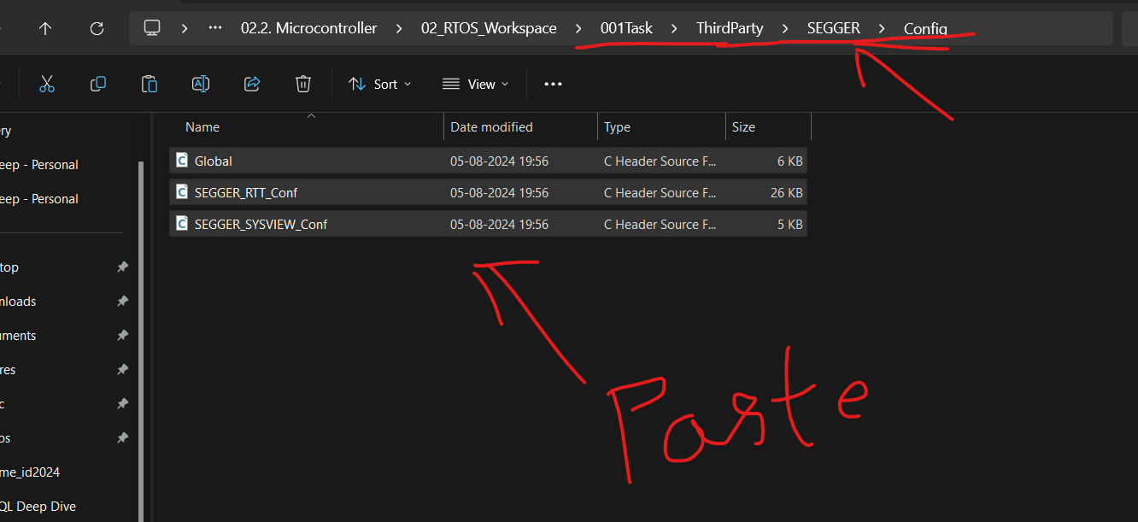

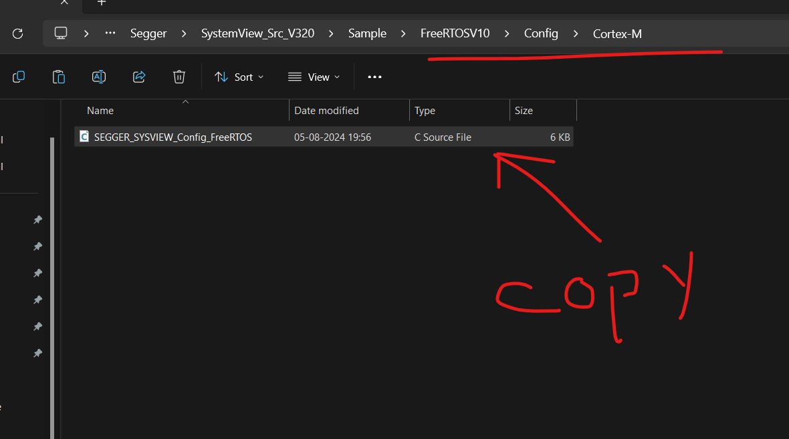

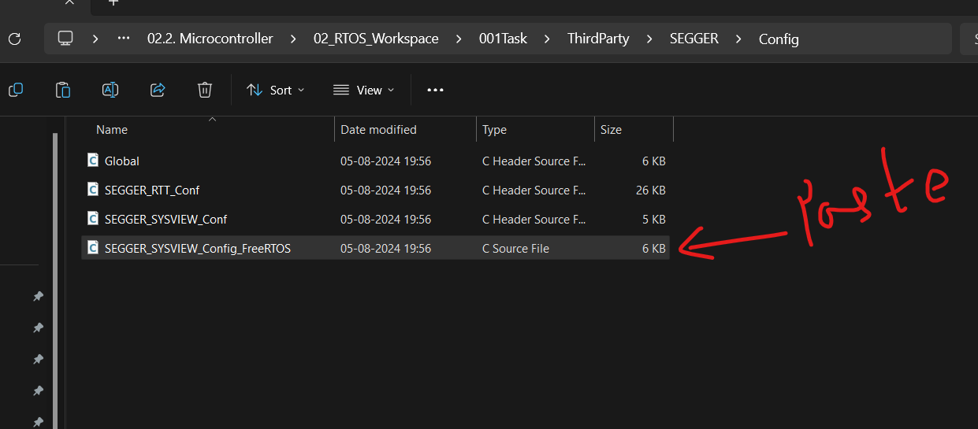

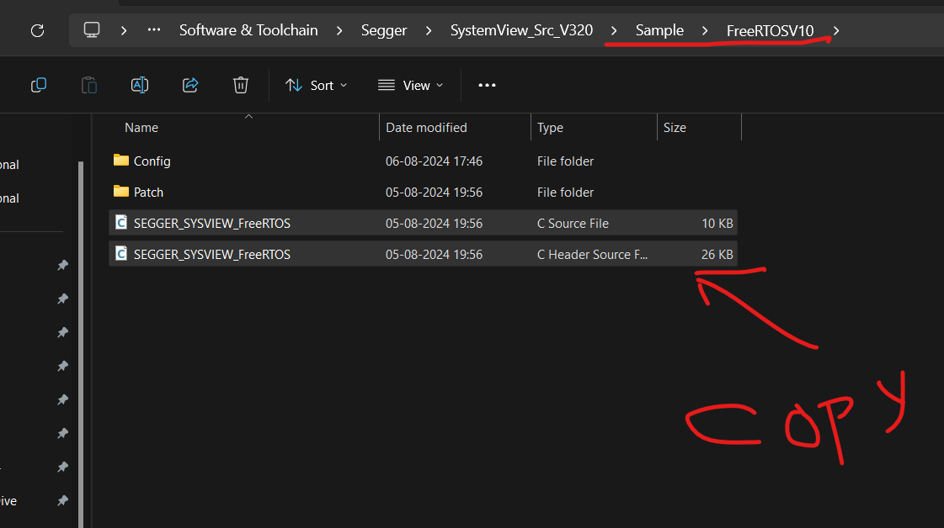

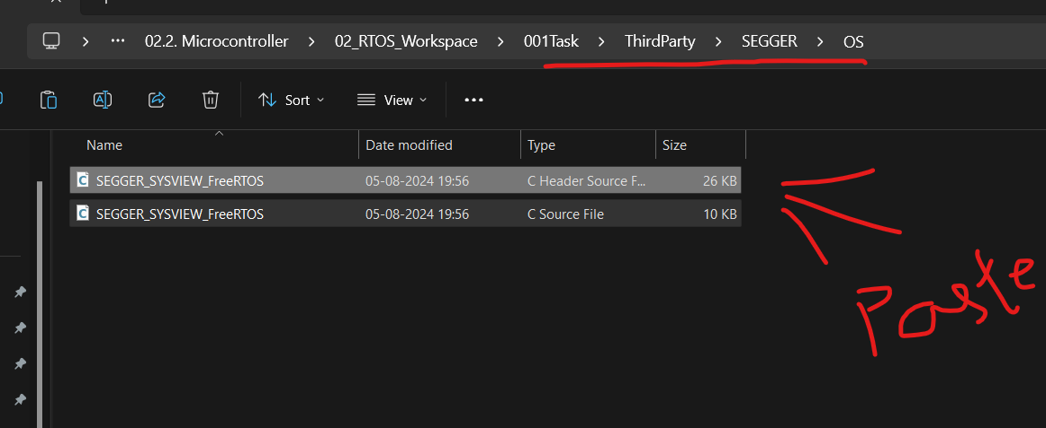

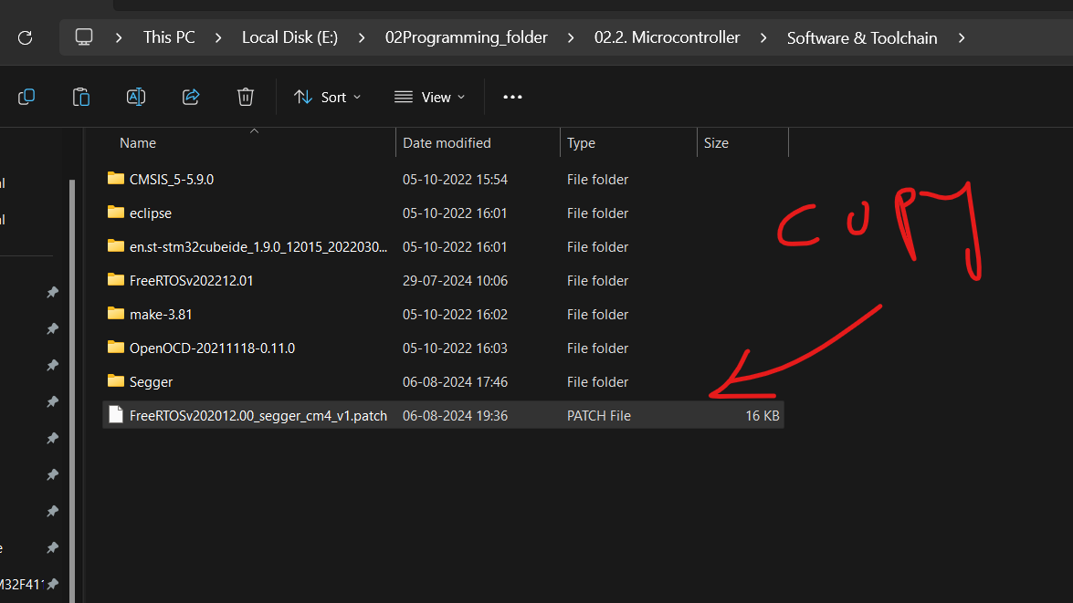

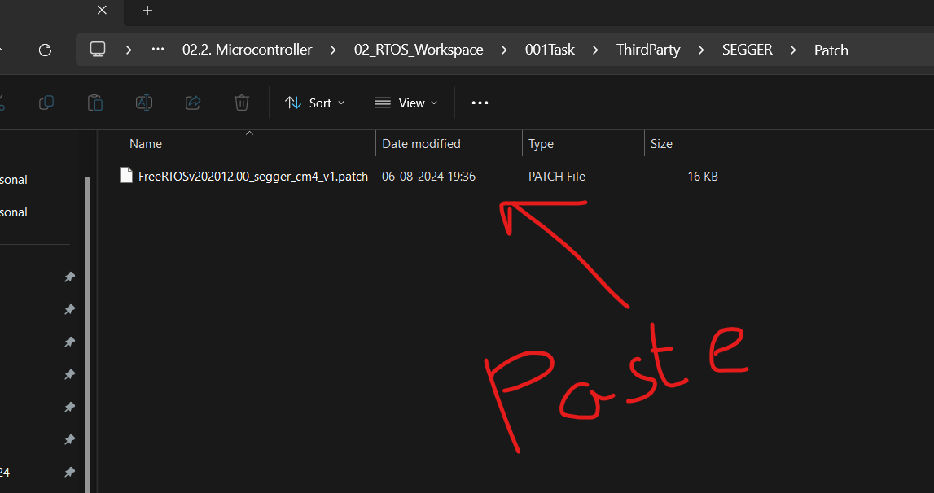

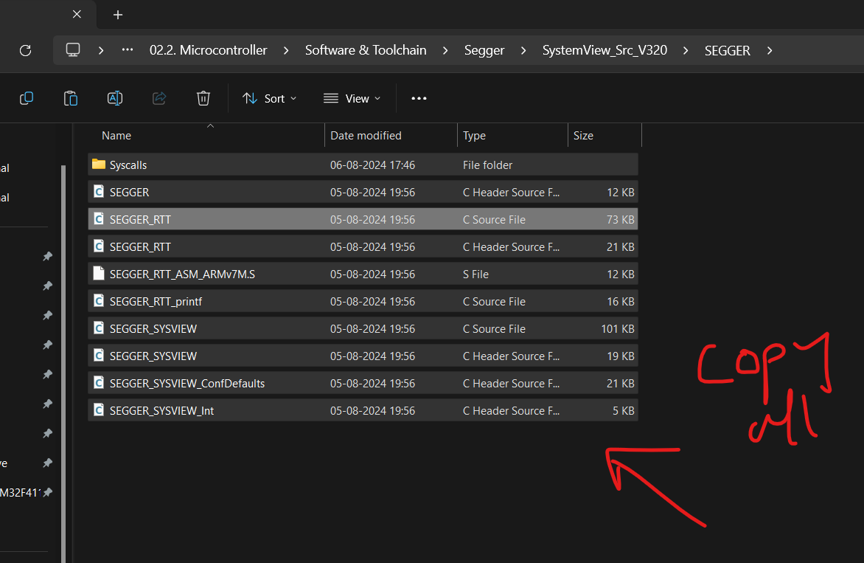

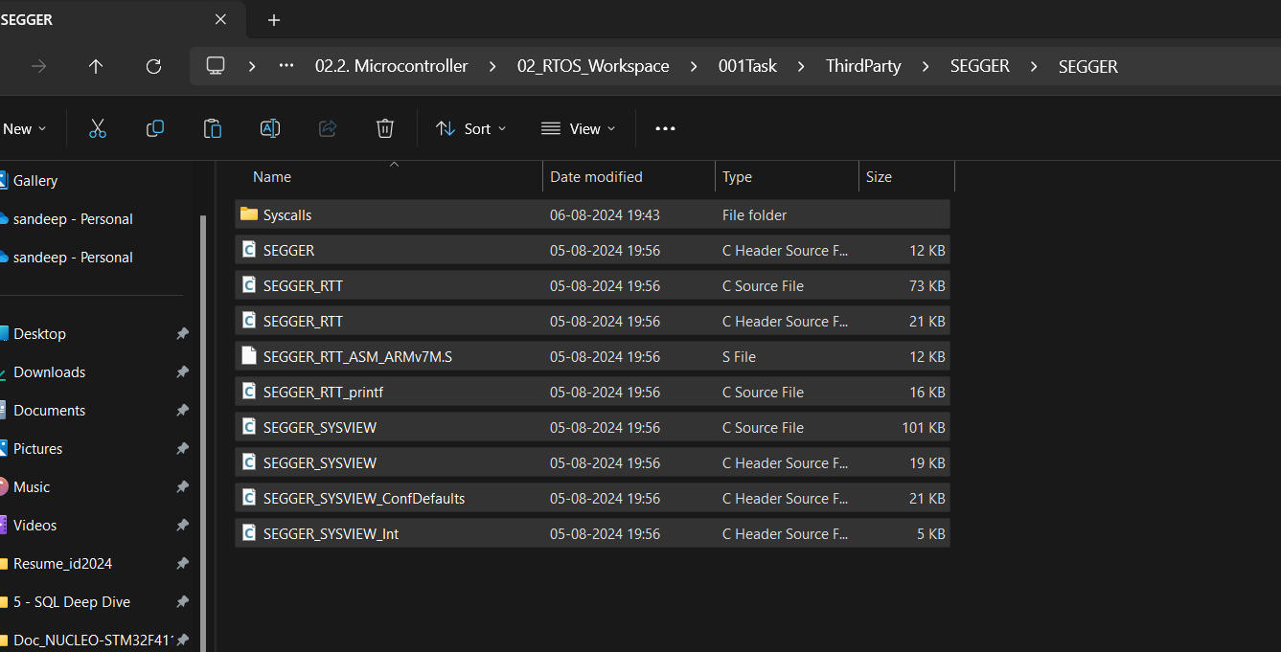

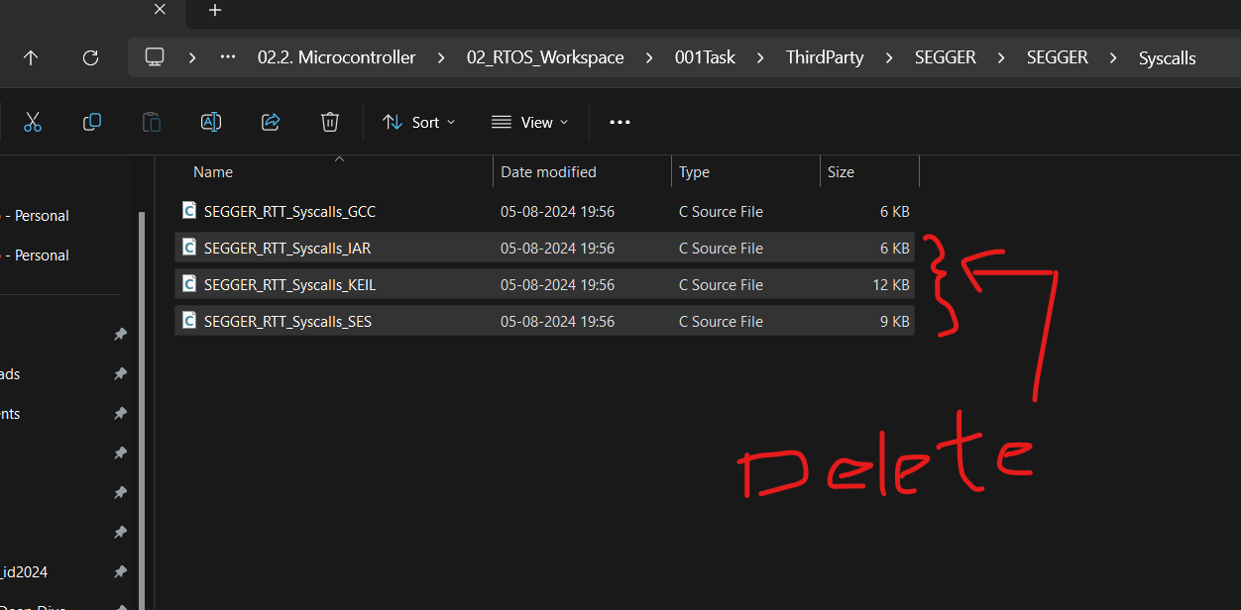

Step -2: Patching FreeRTOS files

We need to Patch some of the FreeRTOS files with patch file given

1. FreeRTOSv202012.00_segger_cm4_v1.patch this patch file actually contains SEGGER trace tool related a patches to the FreeRTOS source files.Now we have to apply this patch to the FreeRTOS source files.

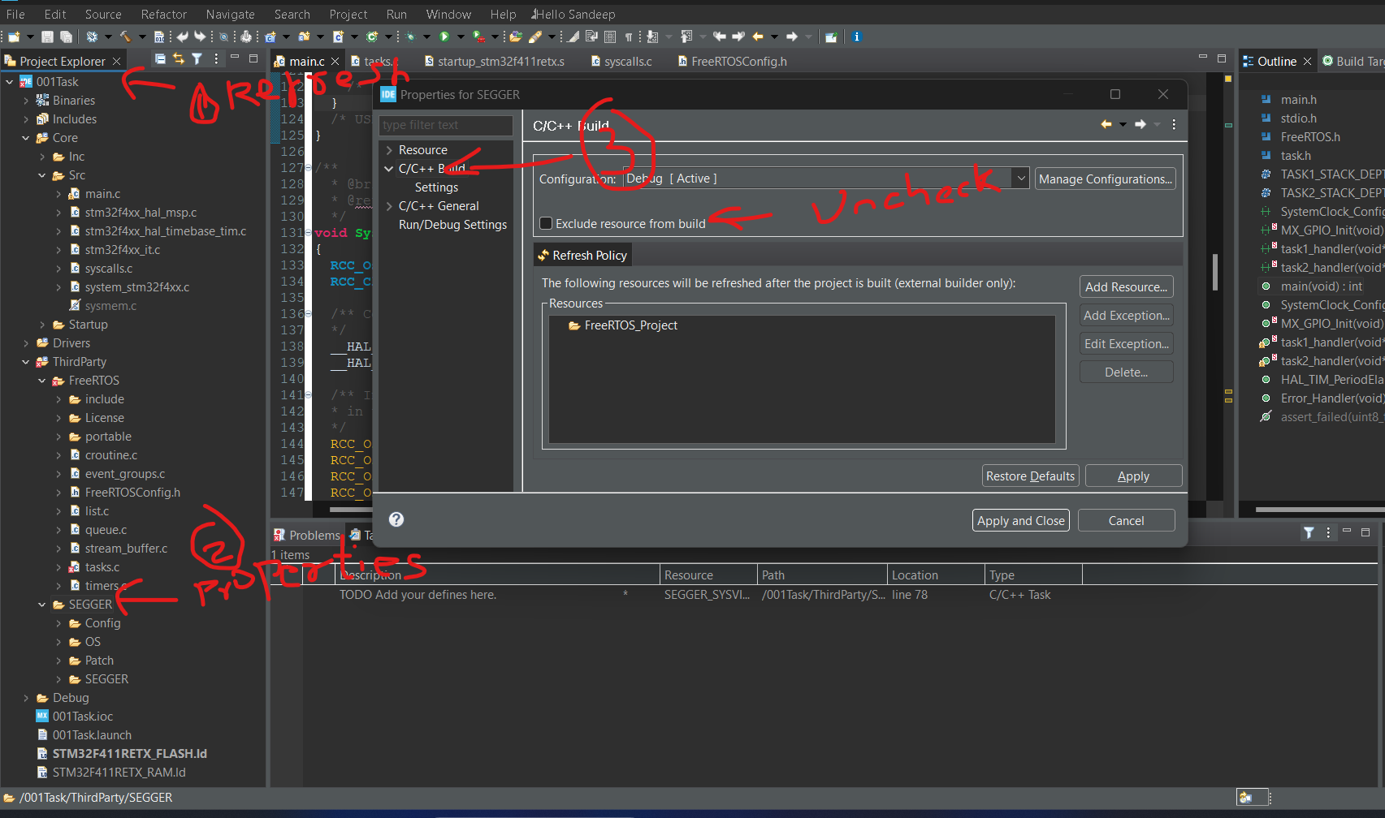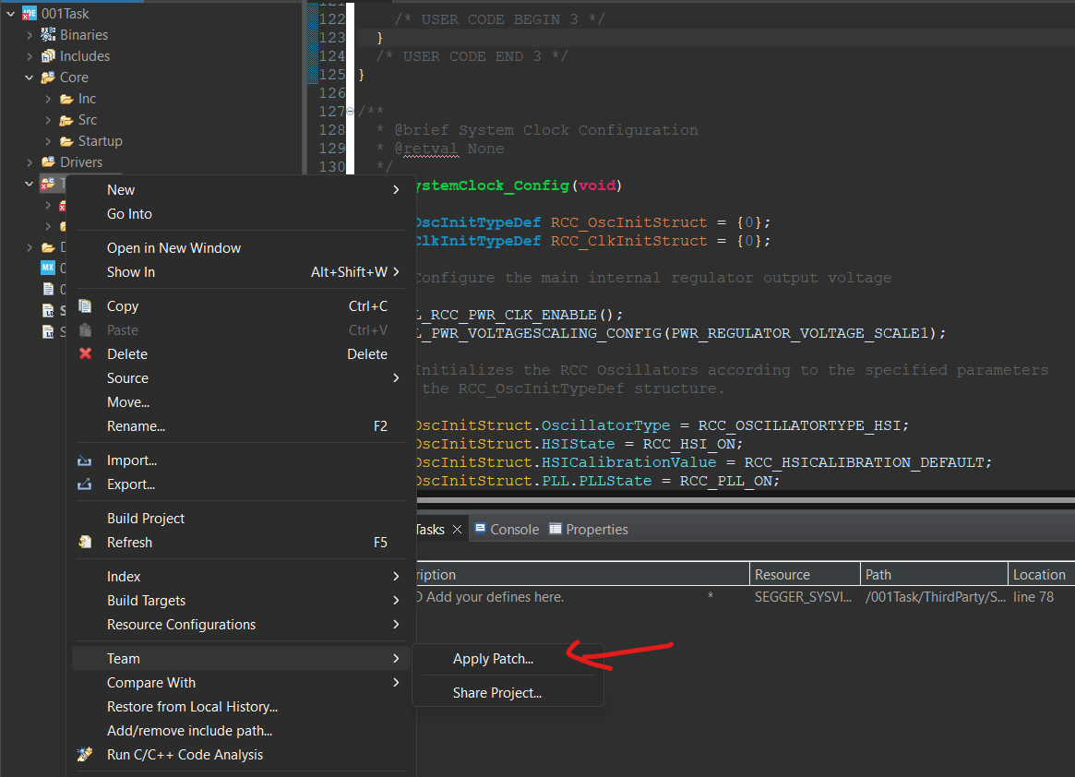

1. 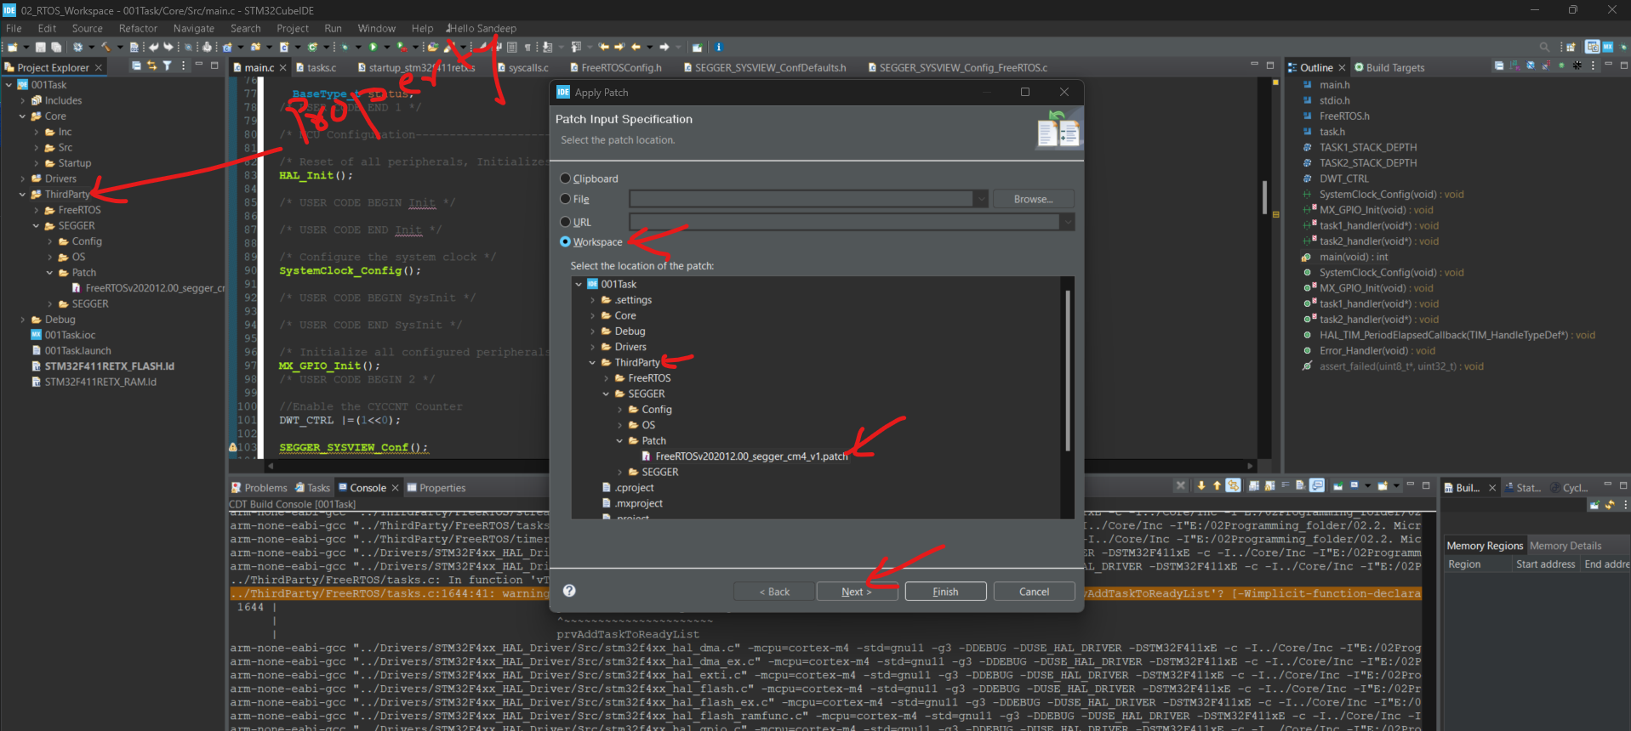

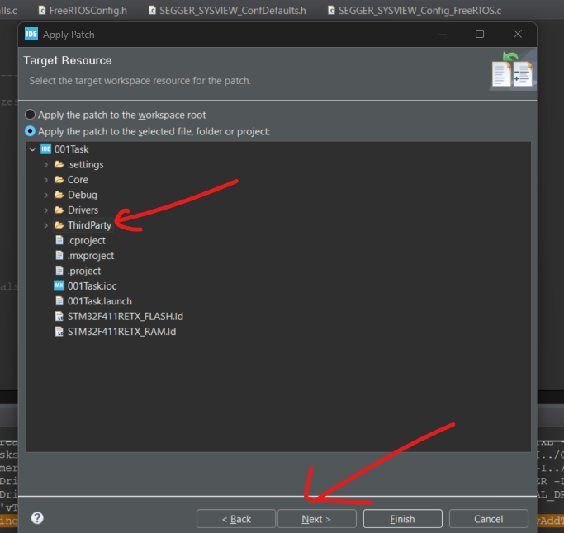

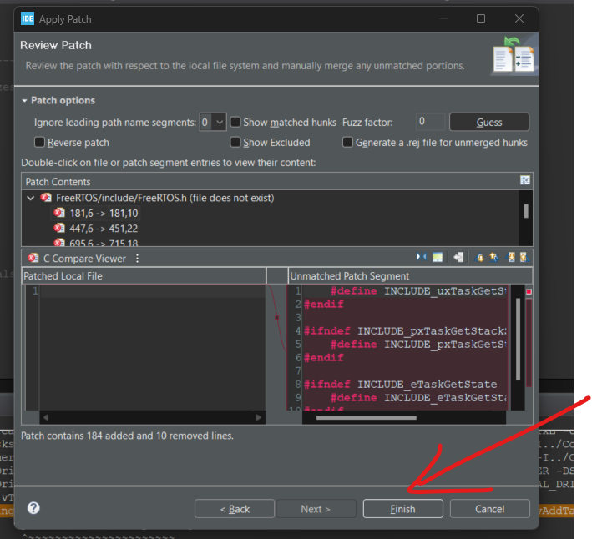

Step -3: FreeRTOSConfig.h Settings

1. SEGGER_SYSVIEW_FreeRTOS.h header must be included at the end of FreeRTOSConfig.h or above every include of FreeRTOS.h It defines the traces macros to create SYSTEMVIEW events

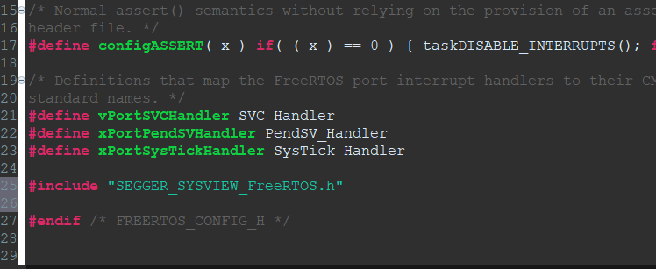

1. In freeRTOSConfig.h include the below macros.

#define INCLUDE_xTaskGetIdleTaskHandle 1

#define INCLUDE_pxTaskGetStackStart 1

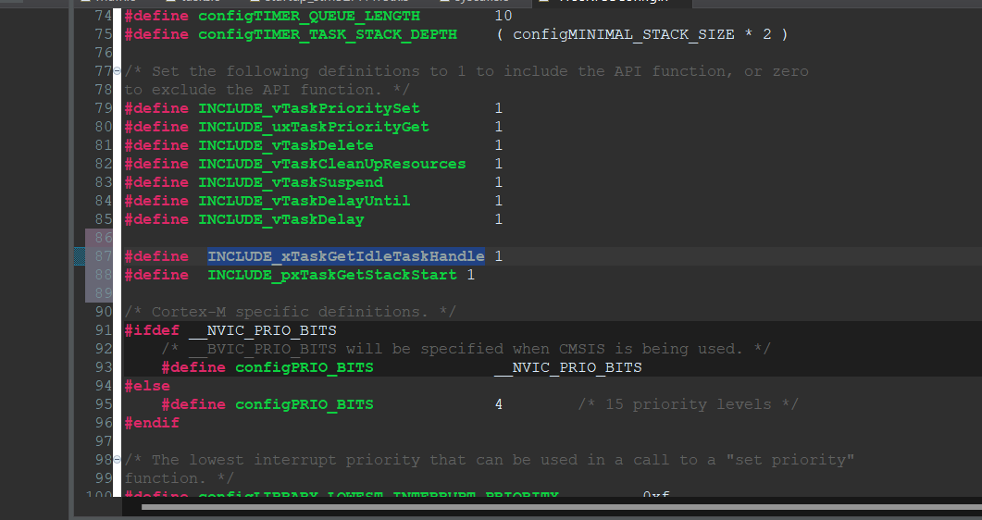

These two macro's activate a these features in the real-time kernel.So, they actually activate some of the code blocks in the real time kernel to include these functionalities which are required by the SEGGER. If these macros are set to 0, then the FreeRTOS build doesn't contain the source codes related to these functionalities.That's why, these two should be set to one.

Step -4: MCU and Project specific Settings

1. Mention which processor core your MCU is using in SEGGER_SYSVIEW_ConfDefaults.h

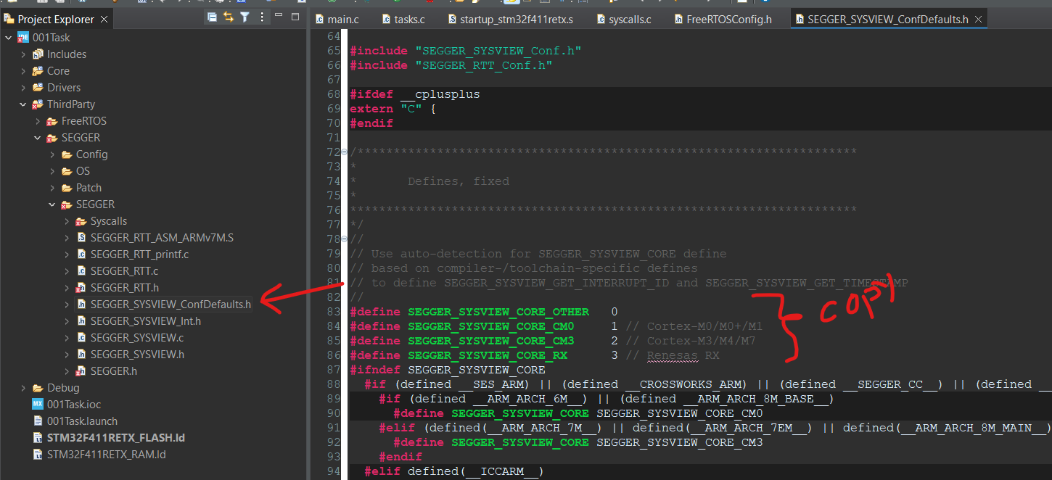

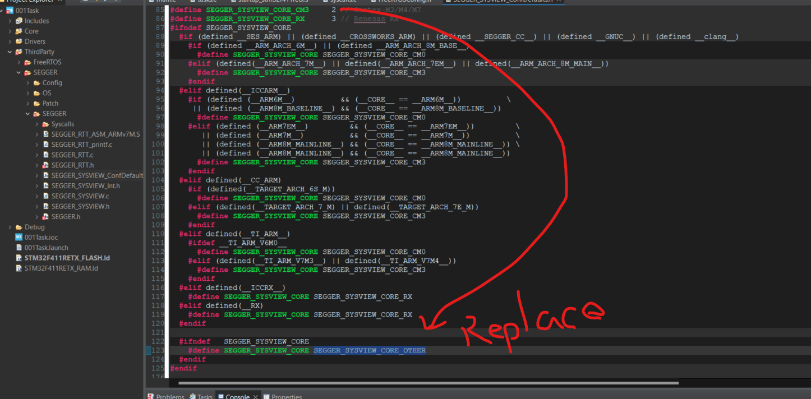

2. Do systemView buffer size configuration in SEGGER_SYSVIEW_ConfDefaults.h in

(SEGGER_SYSVIEW_RTT_BUFFER_SIZE).

RTT_BUFFER_SIZE. RTT_BUFFER_SIZE buffer size is set to a 1024 bytes. That means, this

is the buffer used to collect all the events in the Targets RAM. In the targets RAM, a

1024 bytes of memory will be allocated and where the events will be recorded, and then it will be sent to the Host software.

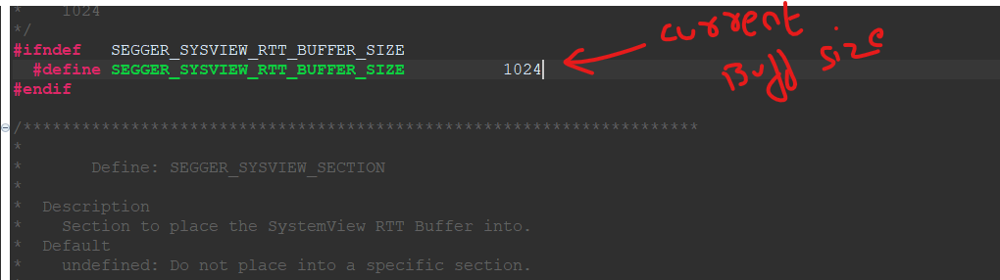

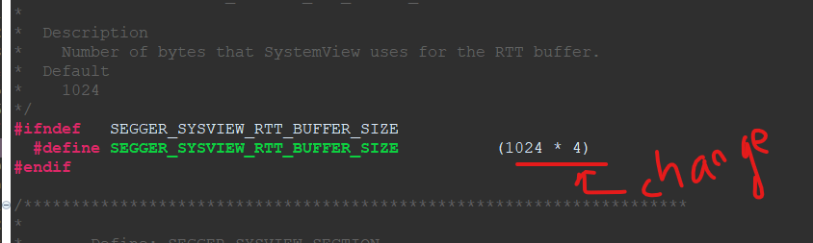

3. Configure some of the application specific information in SEGGER_SYSVIEW_Config_freeRTOS.c

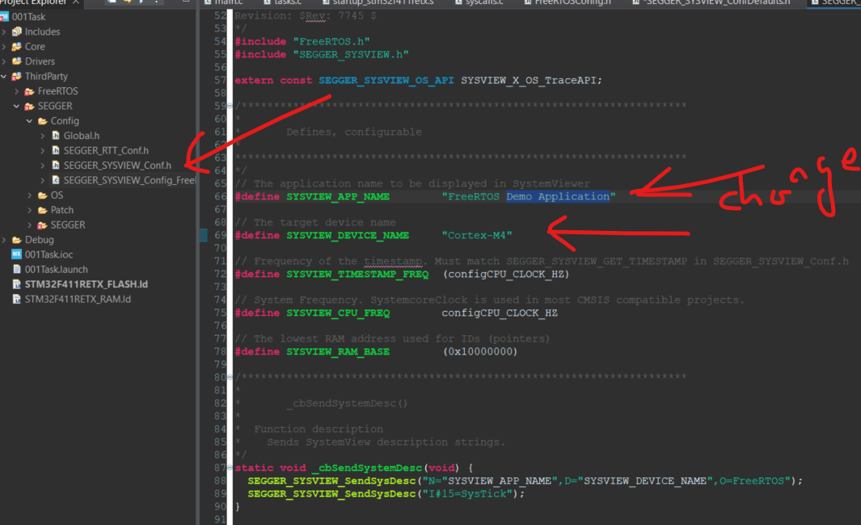

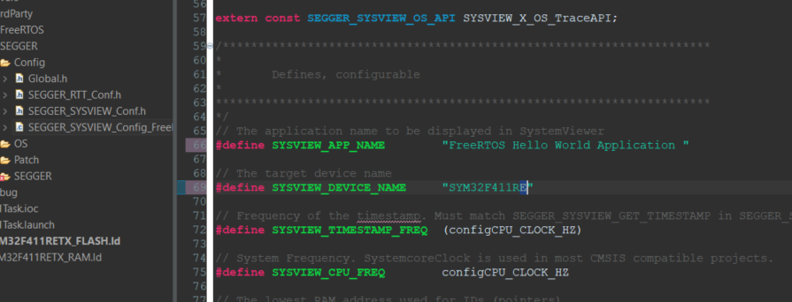

Step -5: Enable the ARM Cortex M3/M4 Cycle Counter

* This is required to maintain the time stamp info of application events. SystemView will use the Cycle counter register value to keep the stamp information of the events
* DWT_CYCCNT register of ARM Cortex M3/m4 processor stores the number of clock cycles that happened after the processor’s reset.
* By default, this register is disabled.

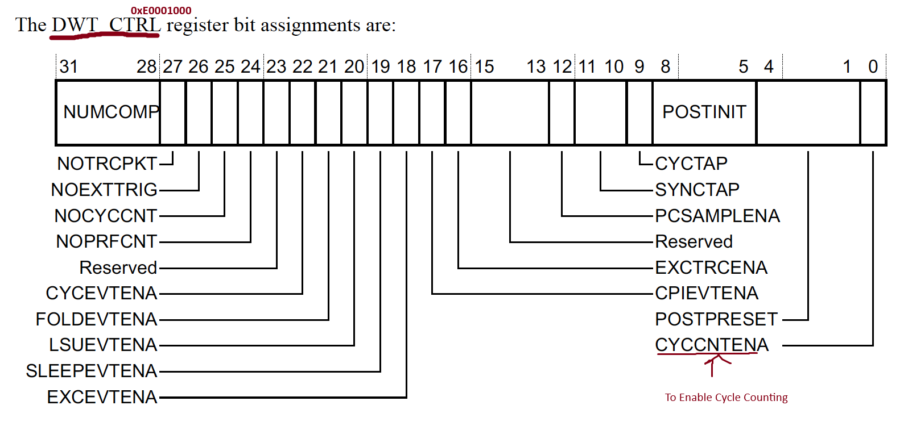

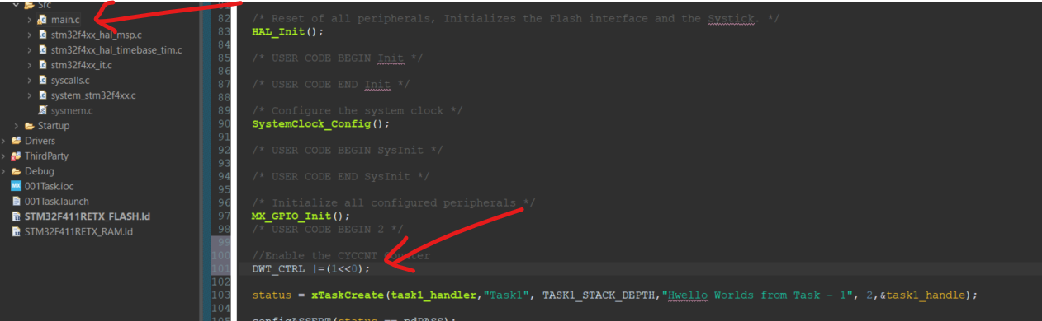

Step -6: Start The Recording of Events

1. To Start the recording of your FreeRTOS application, call the below SEGGER APIs.

* SEGGER_SYSVIEW_Conf();
* SEGGER_SYSVIEW_Start();

The Segger Sysview events recording starts only when you call SEGGER_SYSVIEW_Start(). We Will call this from main.c before calling any FreeRTOS API

Step -7: Compile and Debug

1. Make sure that include path settings are set.
2. Compile and flash your FreeRTOS + SystemView application
3. Go to debugging mode using your IDE
4. Hit run and then pause after couple of seconds.

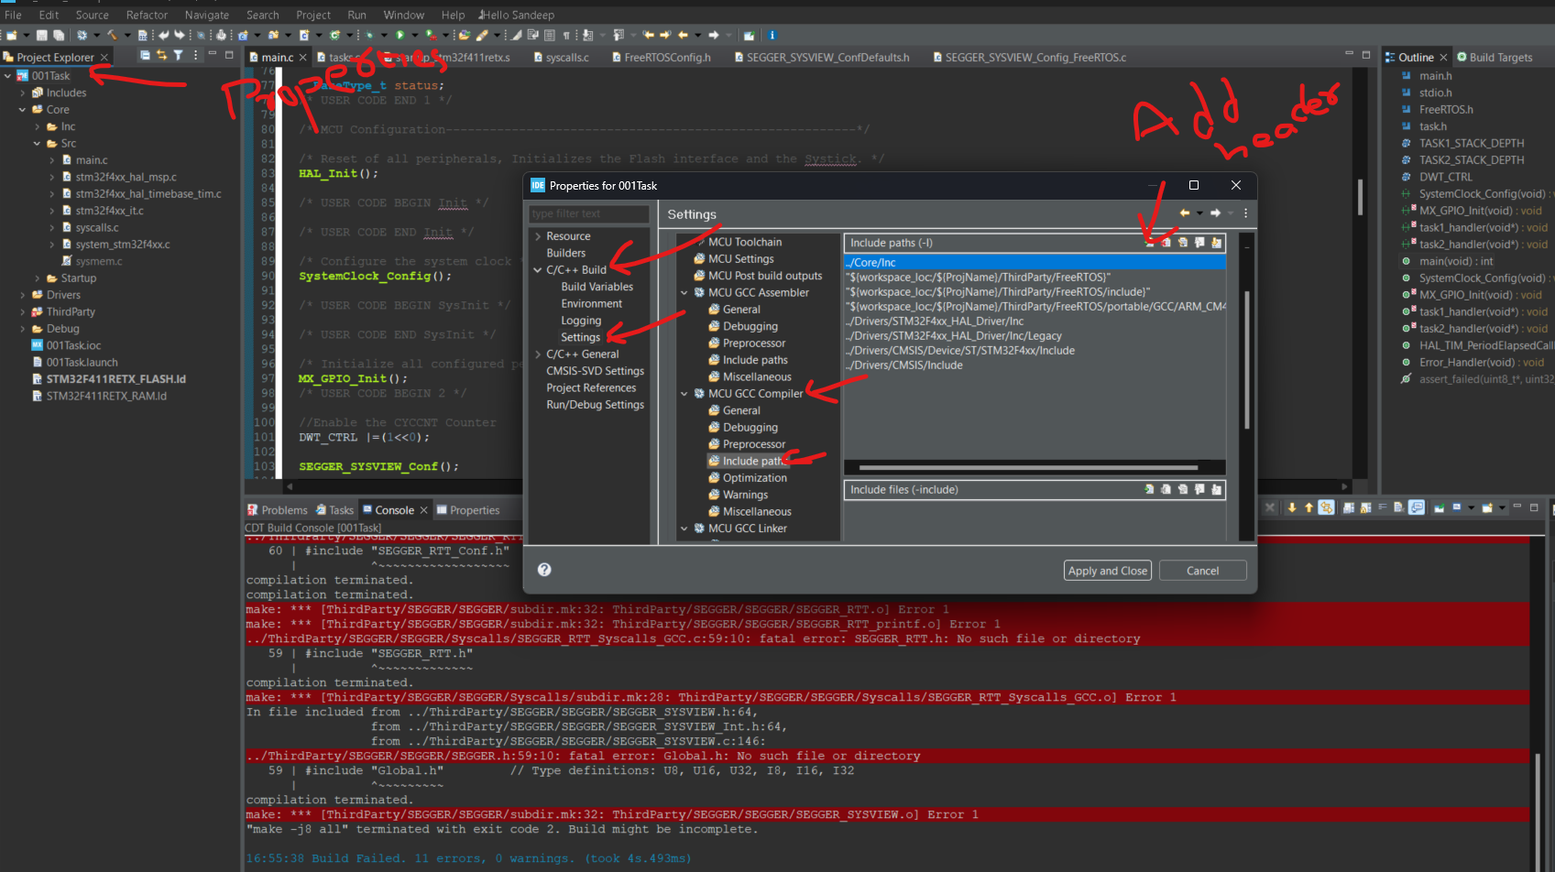

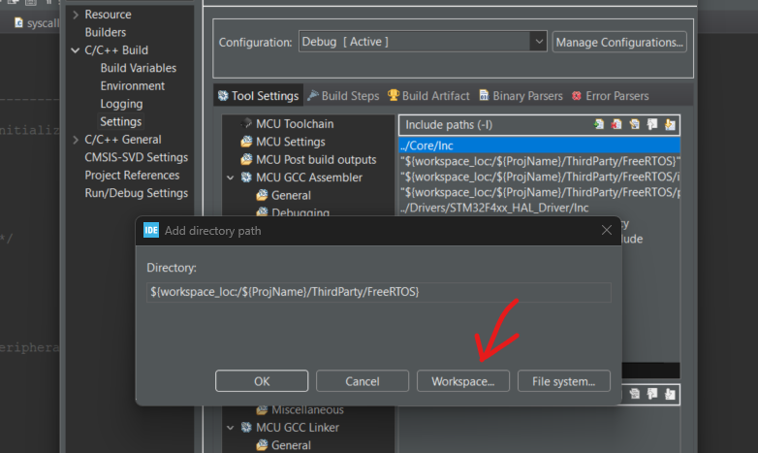

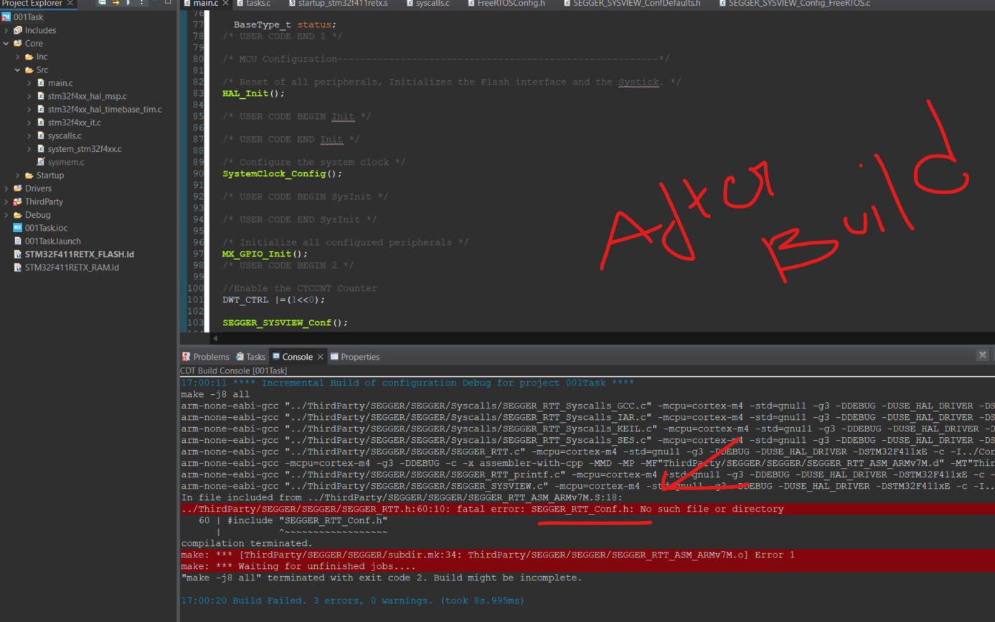

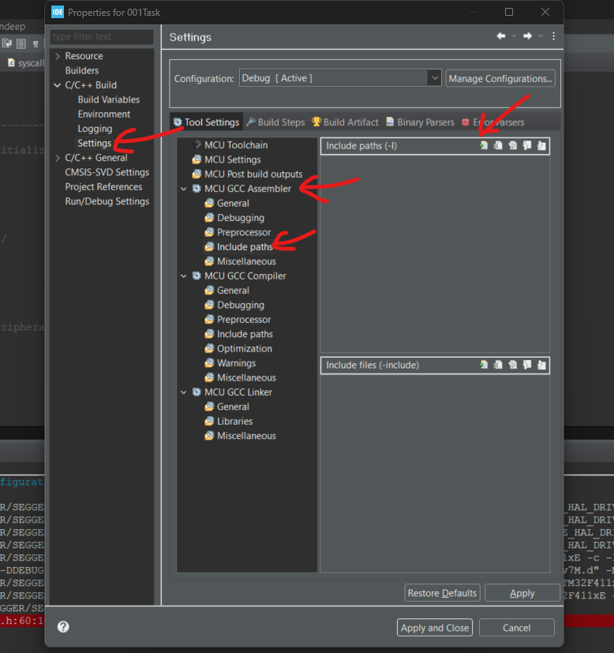

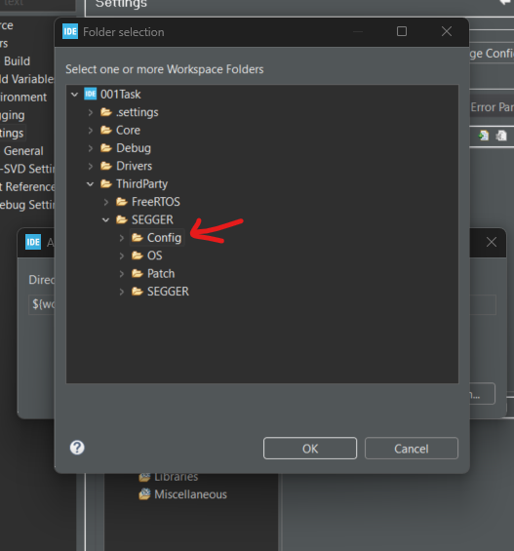

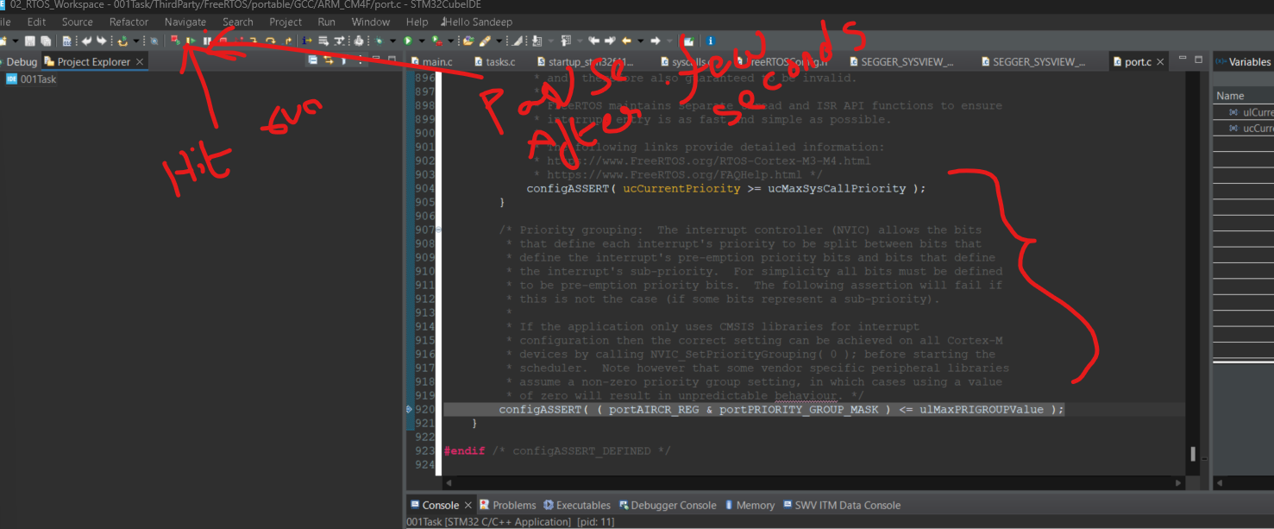After building we’ll get below error, it’s because **vInitPrioGroupValue**(); is generally done by Priority base scheduler but since SEGGER_SYSView_start is placed befoir XtaskCreate we need to do below.

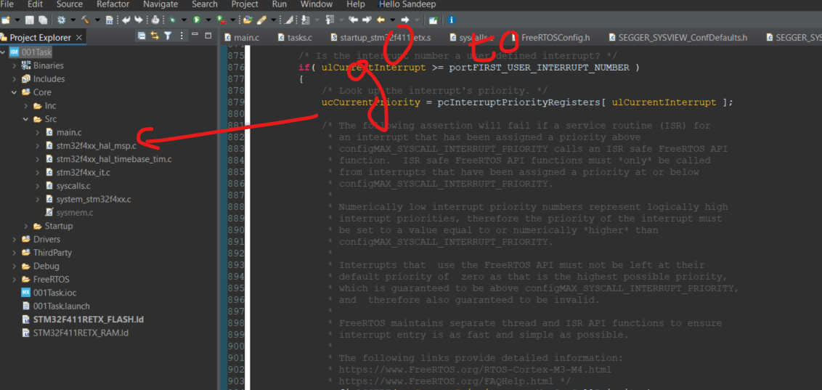

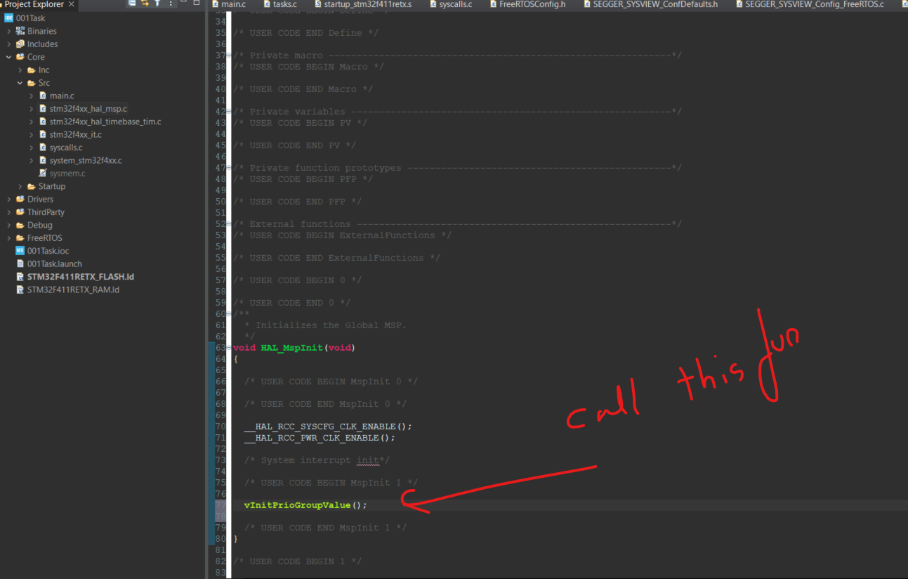

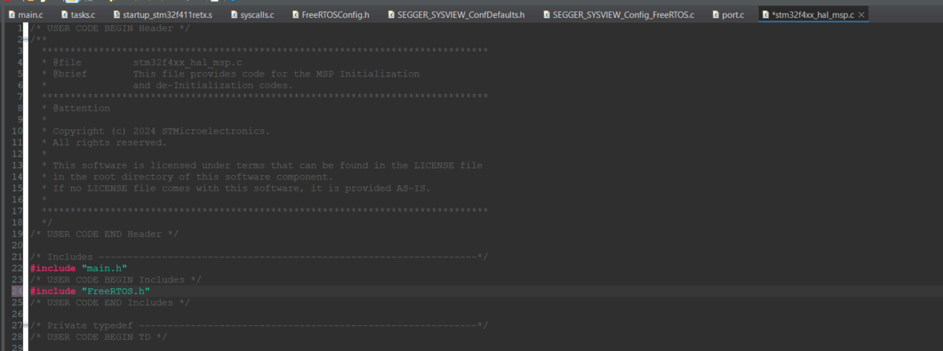

After Running and Suspending Debugging We’ll get as below.

Step -8: Collect the recorded data (RTT buffer)

**You can do this via continuous recordong or Single-short recording.**

Single-shot recording:

1. Get the SystemView RTT buffer address and the number of bytes used.(Normally _SEGGER_RTT.aUp[1].pBuffer and _SEGGER_RTT.aUp[1].WrOff ).
2. Take the memory dump to a file.
3. Save the file with .SVDat extension
4. use that file to load into SystemView HOST software to analyze the events.

